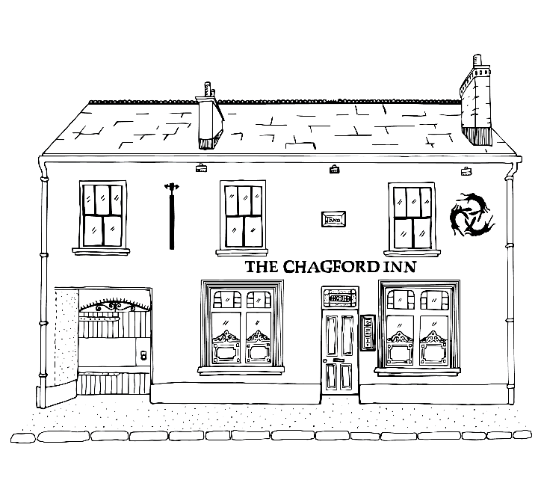
THE CHAGFORD INN
Children’s Menu

Starters
Garlic Bread - £2.95
Veg Sticks with Dip - £2.95
Soup of the Day - £2.95
Mains
Pea Risotto -£7

Tomato Pasta - £6
Homemade Burger with Cheese -£8
(Or if there is something that takes our smaller diner’s interest on the adult’s menu then please mention to a member of the team and we can ask the kitchen for a smaller portion)

Drinks
Cordial (still/sparkling) – 50p
Milk - £1
Cawston’s Apple and Mango - £2.00

Desserts
Ice Cream – 1 Scoop - £3
Ask for Todays Flavours
Chocolate Brownie - £5

